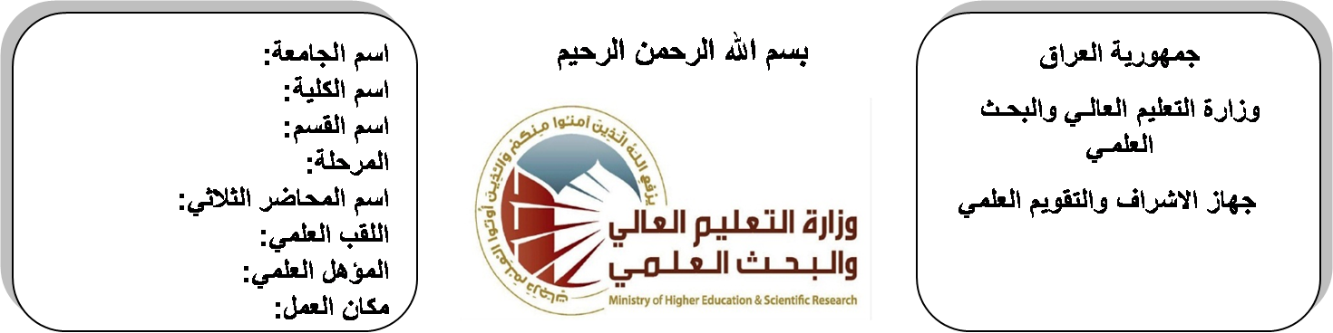

**University: Diyala University**

**College: College of Engineering**

**Department: Electronic Engineering**

**Stage: third**

**Lecturer name:** **Hanan Badeea Ahmed**

**Qualification: M.Sc**

**Place of work: Electronic Dept.**

**Republic of Iraq**

**Ministry of Higher Education**

**& Scientific Research**

**(( Annual teaching plan form))**

|  |  |  |  |  |
| --- | --- | --- | --- | --- |
| **Lecturer Name** | **Hanan Badeea Ahmed** | | | |
| **Email** | **Hanan1980@yahoo.com** | | | |
| **Subject** | Engineering & Numerical Analysis | | | |
| **Aims** | **The aim of this subject is to make the students ready to undestand and comprehend the scientific theories and their applications related to their field of the study.** | | | |
| **Textbooks** | Advanced Mathematics by Wiley. | | | |
| **Additional Textbooks** | Calculus by James Stewart ,Barbara Frank. | | | |
| **Assessments** | **First Semester** | **Second Semester** | **Laboratory** | **Final Exam** |
| 20% | 20% |  | 60% |
| **Notes** |  | | | |

**Schedule Weekly Lessons - First Semester**

|  |  |  |  |  |
| --- | --- | --- | --- | --- |
| **Week** | **Date** | **Lectures** | **Lab. Experments** | **Notes** |
| 1 | **29/9/** | Fourier transform |  |  |
| 2 | **5/10/** | Properties , convolution theorm |  |  |
| 3 | **12/10/** | power spectral density and correlation |  |  |
| 4 | **19/10/** | signals and linear system ,applications. |  |  |
| 5 | **26/10/** | The Z- transform |  |  |
| 6 | **2/11/** | Region of convergence, properties of Z-transform |  |  |
| 7 | **9/11/** | Z-transform pairs, the inverse of Z-transform |  |  |
| 8 | **16/11/** | analysis and discrete- time systems, applications |  |  |
| 9 | **23/11/** | Numerical Analysis |  |  |
| 10 | **30/11/** | Solution of non-linear eguations (Iteration ,bisection and Newton – Raphson). |  |  |
| 11 | **7/12/** | Finite differences |  |  |
| 12 | **14/12/** | Numerical differentiation and Integration |  |  |
| 13 | **21/12/** | Numerical Solution of 1st order ordinary differential equations |  |  |
| 14 | **28/12/** | Matrix anaylsis |  |  |
| 15 | **4/1/** | Review of matrix theory |  |  |
| 16 | **11/1/** | linear transformation |  |  |
| Half Year holiday | 15/1/ to  1/2/ |  |  |  |

**Lecturer Signature Head of Dept. Signature Dean Signature**

**Schedule Weekly Lessons - Second Semester**

|  |  |  |  |  |
| --- | --- | --- | --- | --- |
| **Week** | **Date** | **Lectures** | **Lab. Experments** | **Notes** |
| 1 | **15/2/** | egin values & egin vectors |  |  |
| 2 | **22/2/** | laplace transform of matrices, application of matrices to electric cct. |  |  |
| 3 | **1/3/** | Definition, frequency distribution (relative & commulative, mean, standard deviation). |  |  |
| 4 | **8/3/** | Definition, frequency distribution (relative & commulative, mean, standard deviation). |  |  |
| 5 | **15/3/** | Definition, mutually exclusive & conditional probability |  |  |
| 6 | **22/3/** | permutations & combinations, probability distribution, normal & Poisson distributions |  |  |
| 7 | **29/3/** | Function of complex variable , complex differentiation |  |  |
| 8 | **5/4/** | analytic function & its properties, integration in the complex plane |  |  |
| 9 | **12/4/** | Cauchy's theorem , Cauchy's integral, taylor's theorem, Laurent series, the residue theorem. |  |  |
| 10 | **19/4/** | Legendre's equation, Legendre's polynomials |  |  |
| 11 | **26/4/** | Bessel function of the first and second order kinds, Bessel function properties. |  |  |
| 12 | **3/5/** | Partial differential equation |  |  |
| 13 | **10/5/** | Wave equation |  |  |
| 14 | **17/5/** | laplace's equation |  |  |
| 15 | **24/5/** | solution of boundary condition problems |  |  |
| 16 | **1/6/** | solution by separation of variables |  |  |

**Lecturer Signature Head of Dept. Signature Dean Signature**